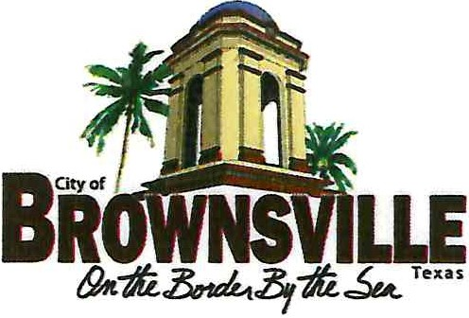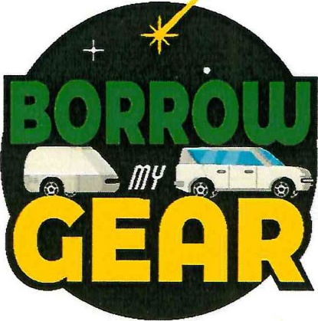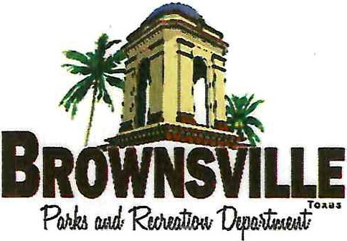
/
BORROW I EXPLORE I RETURN

EQUIPMENT LOAN AGREEMENT
Please Read Carefully Before Signing

LIABILITY RELEASE

- I hereby release the City of Brownsville and all its agents, partners, officers, assistants, and employees from any and all liability for damage and injury to myself or to any person or property resulting from negligence, the selection, adjustment, and use of this equipment, accepting myself the full responsibility for any and all such damage and injury which may result.
- I agree to reimburse and hold harmless City of Brownsville for any loss or damage of any kind, other than reasonable "wear and tear" resulting from the use of this equipment.
- I understand that there are inherent risks involved in the sport for which this equipment is to be used and that injuries are a common and ordinary occurrence of the sport, and I freely assume those risks.
LOAN CONDITIONS

- Equipment loans are accepted only with a major credit card number. A refundable damage deposit of $250.00 is required if the equipment is returned in sound condition as rented. Please notate any damages prior to rental. A charge for damages or the value of the replacement will be made only if equipment is lost, damaged or stolen.
- I understand that my credit card will be charge $250.00 and it will be processed, {not a hold on the card) and a refund will have to be issued {unless using cash deposit) which may take up to 30 days.
- I understand or will ask City of Brownville staff to supply me with the manufacturer's instruction sheet (when available) to explain the proper function, care and use for which the

equipment was designed, I agree to use the equipment only in accordance with its proper function and designed purpose.
- I will pay the replacement cost of any lost or damaged equipment at full retail value. See attached Price List.
- I agree to return all rental equipment by the agreed return date in clean and dry condition and to pay the cleaning charge of $50.00 if equipment is returned unboxed, dirty, etc. which will be deducted from the deposit.
- The City of Brownville may amend its loan agreement or policy at any time. I understand that I must abide by any of these amendments or changes.
I, the undersigned, have read and understand this Agreement and its contents. This is a binding contract that supersedes any other agreements or representations and is intended to provide a comprehensive release of liability. If any part of this contract is deemed unenforceable, all other parts shall be given full force and effect. I sign it of my free will.

LEASEE SIGNATURE: DATE: Click or tap here to enter text.

X
LEASEE SIGNATURE

PARD STAFF SIGNATURE: DATE: Click or tap here to enter text.

X
PARKS AND RECREATION DEPARTMENT STAFF

